The master/slave database replication is a process of copying (syncing) data from a database on one server (the master) to a database on another server (the slaves). The main benefit of this process is to distribute databases to multiple machines, so when the master server has a problem, there is a backup machine with same data available for handling requests without interruption.

Cassandra provides several ways to replicate a database. It can be used for backup purposes and to provide a high availability database server. Here we will see how to install and configure Cassandra replication in two servers.

Replication process requires 2 database servers, we will use Ubuntu as operating system on both servers.

1. **Master Server** - accepts connections from the client with read and write permissions.
2. **Slave Server** - the standby server runs copy of the data from the master server with read-write permission.

**Prerequisites**

* 2 Ubuntu servers - 1 for master and 1 for slave.
* Root privileges on the servers.

**Step 1 - Install Cassandra on Master and Slave Server**

Do the below steps in both Master and Slave server.

* Add the Apache repository of Cassandra

**echo "deb https://downloads.apache.org/cassandra/debian 311x main" | sudo tee -a /etc/apt/sources.list.d/cassandra.sources.list**

* Add the Apache Cassandra repository keys:

**curl https://downloads.apache.org/cassandra/KEYS | sudo apt-key add –**

* Update the repositories:

**sudo apt-get update**

* Install Cassandra:

**sudo apt-get install Cassandra**

* Start the Cassandra service

**sudo service cassandra start**

* Test the Cassandra

**nodetool status**

* Connect to database

**cqlsh**

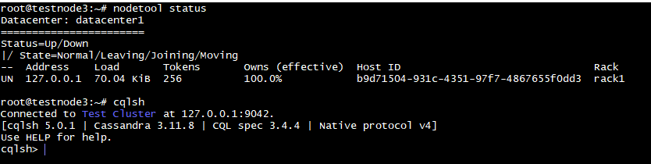

## Step 2 - Configure Master-server

We will configure the **'master server'** with IP address of **<IP-M> , <IP-S>** to process the replication

* Go to the configuration file location

**cd /etc/cassandra**

**vi cassandra.yaml**

* + update

cluster_name = ‘Test Cluster’

listen_address = **<IP-M>**

rpc_address = **<IP-M>**

seeds = **“<IP-M>,<IP-S>”**

Save the file and close it

## Step 3 - Slave-server Configuration

* Configure the slave server like the master server
  + Update

cluster_name = ‘Test Cluster’

listen_address = **<IP-S>**

rpc_address = **<IP-S>**

seeds = **“<IP-S>,<IP-M>”**

Save the file and close it

**NOTE: Make sure that cluster_name is same for both the servers.**

## Step 4 - Synchronize Data from Master server to Slave server

* Restart the Cassandra service in both Master and Slave server

**sudo service cassandra restart**

* Check the cluster status

**nodetool status**

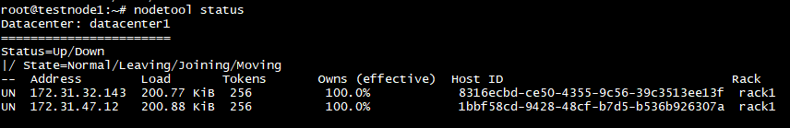

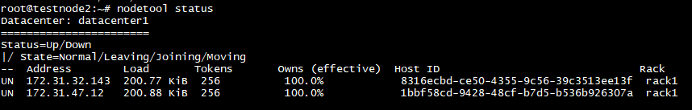

## Step 5 – Testing

* Go to the master server, connect to the DB then run the command below to see the replication info.

**cqlsh <IP-localhost>**

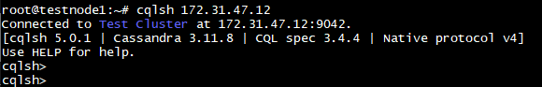

* Check the existing keyspaces on Master server.



* create a new keyspace from the master server and then check that the database exist on the slave server.



* Login to the slave server and check that the tutorialspoint keyspace has been mirrored to the slave server automatically.

